# CS 255 System Design Document Template

This template lays out all the different sections that you need to complete for Project Two. Each section has guidance to prompt your thinking. You will need to continually reference the interview transcript as you work to make sure that you are addressing your client’s needs. There is no required length for the final document. Instead the goal is to complete each section based on what your client’s needs are. Remove this note when you are finished, and replace all bracketed text with the relevant information.

## UML Diagrams

### UML Use Case Diagram

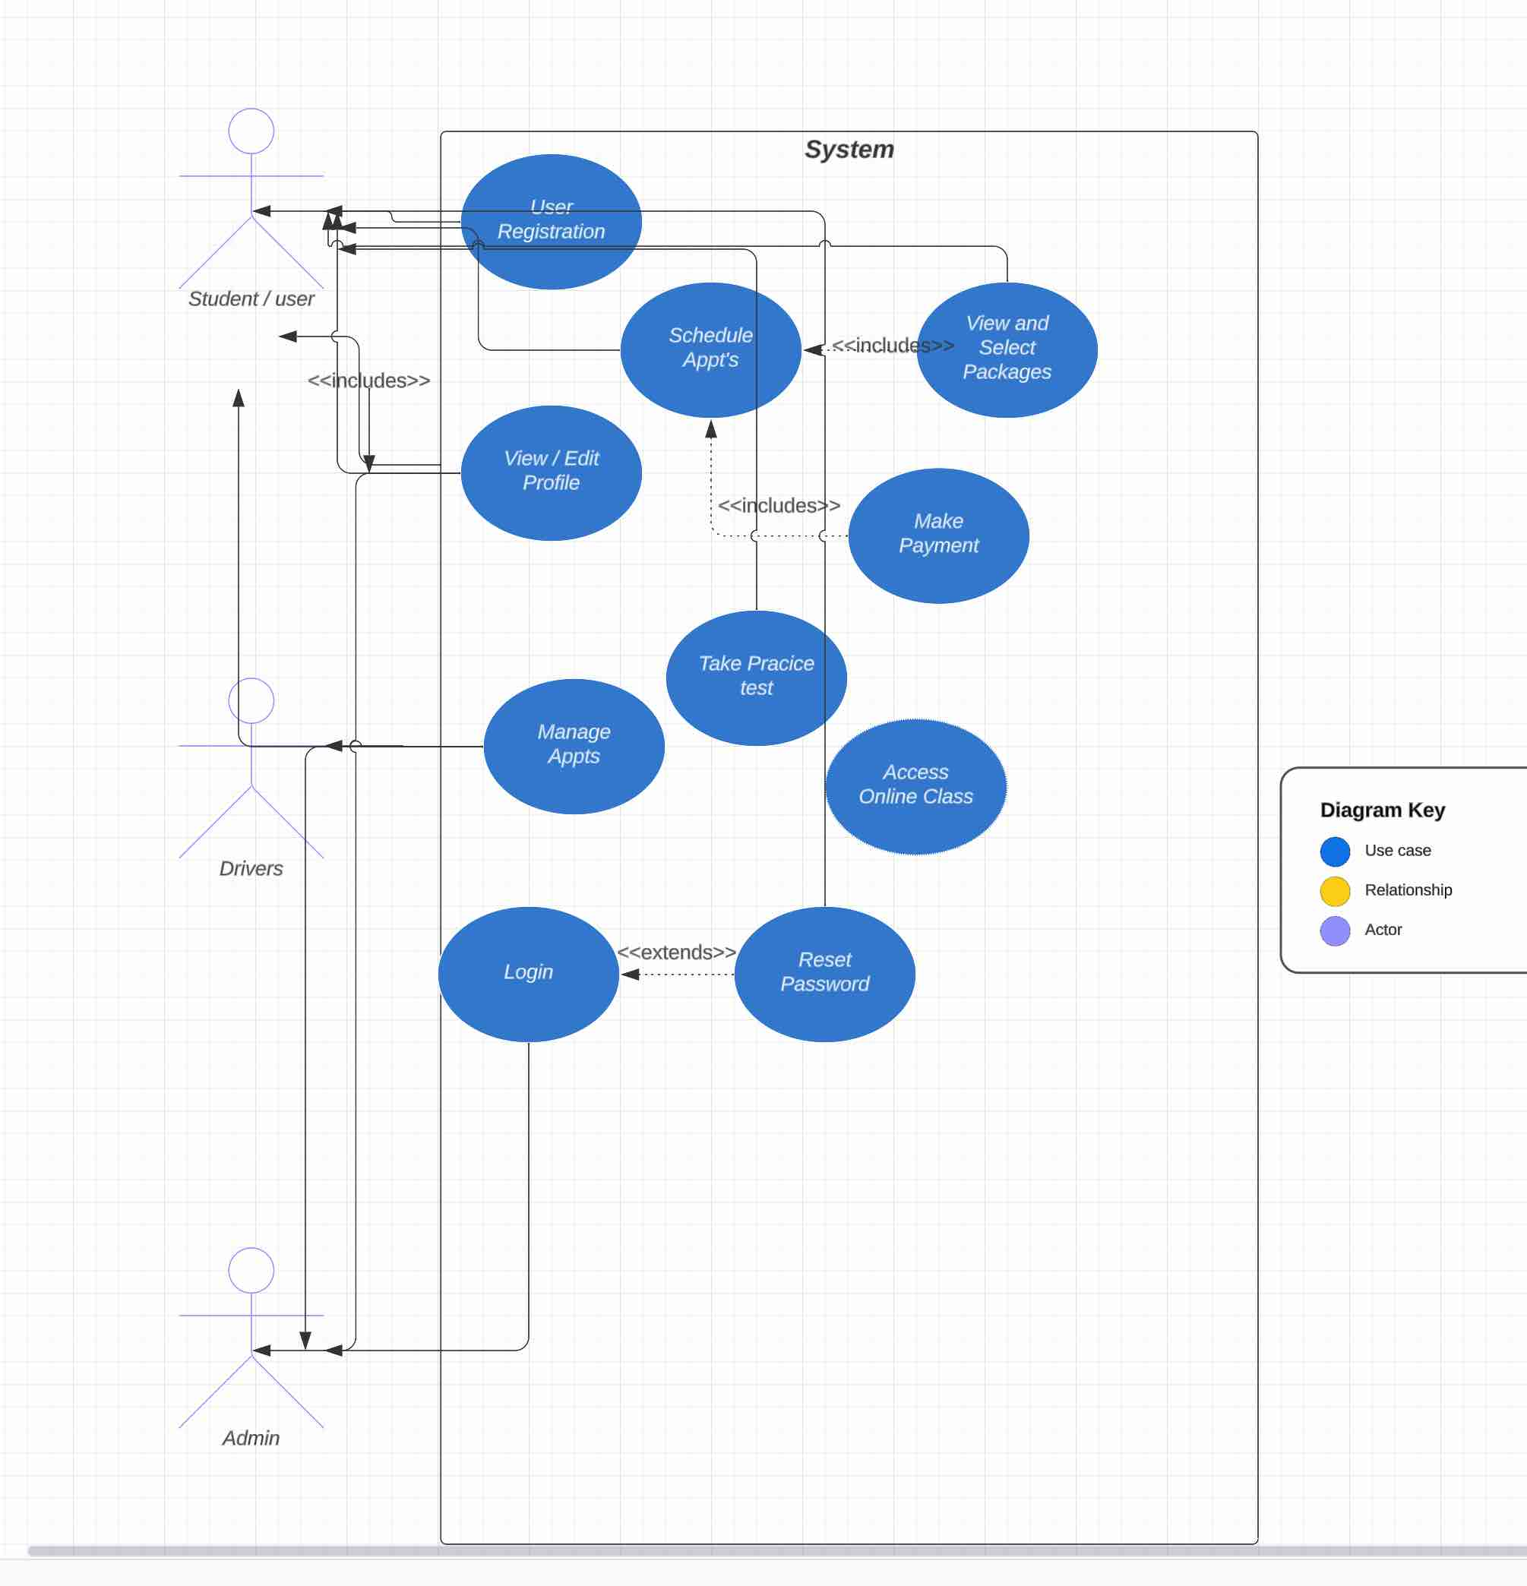

### UML Activity Diagrams

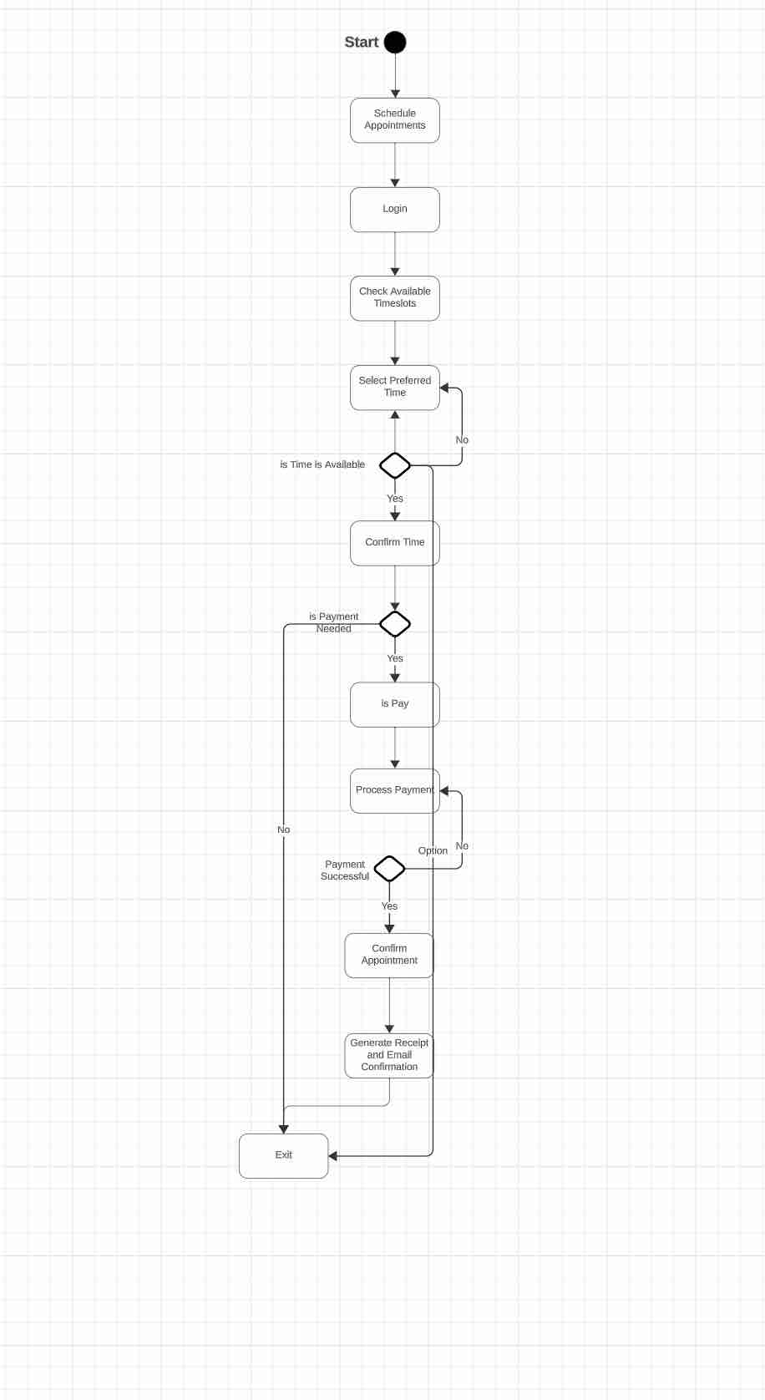

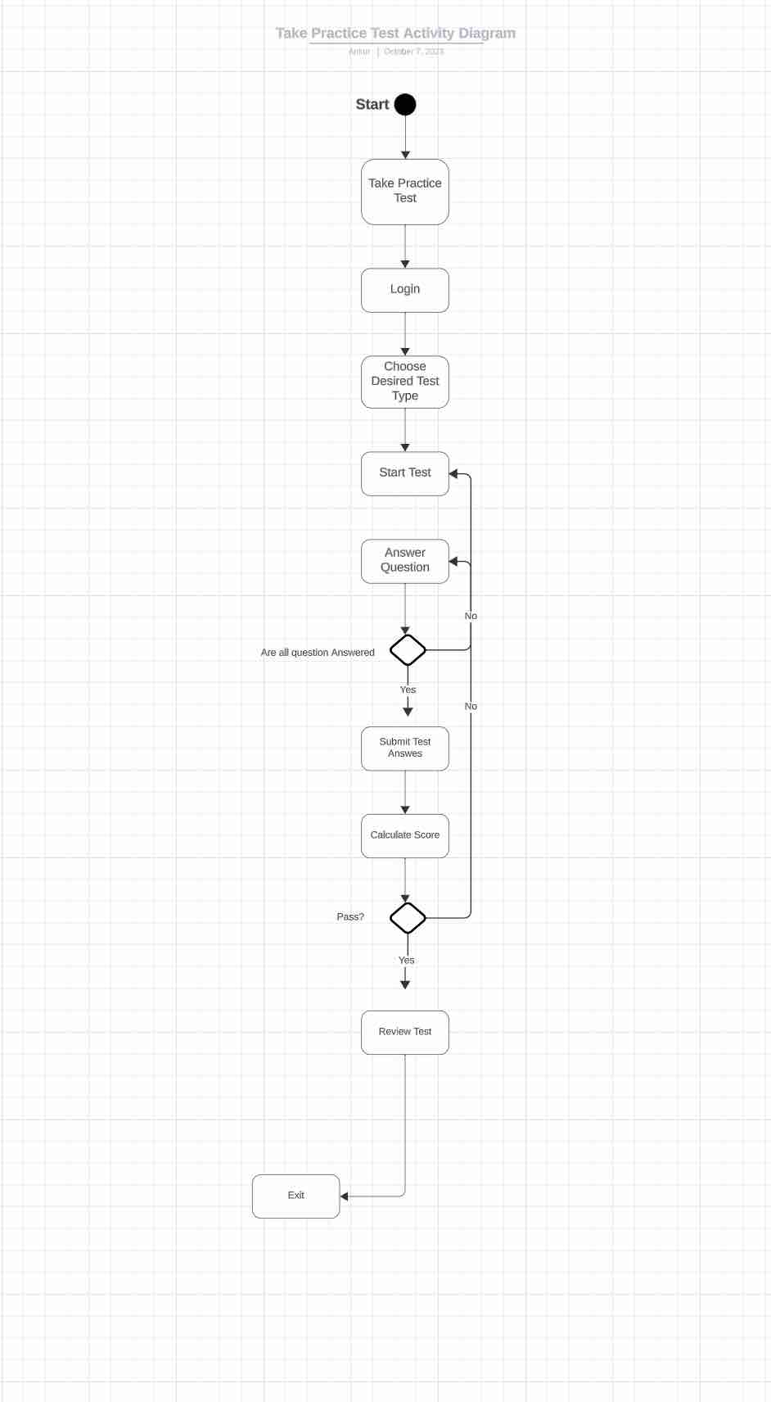

### UML Sequence Diagram

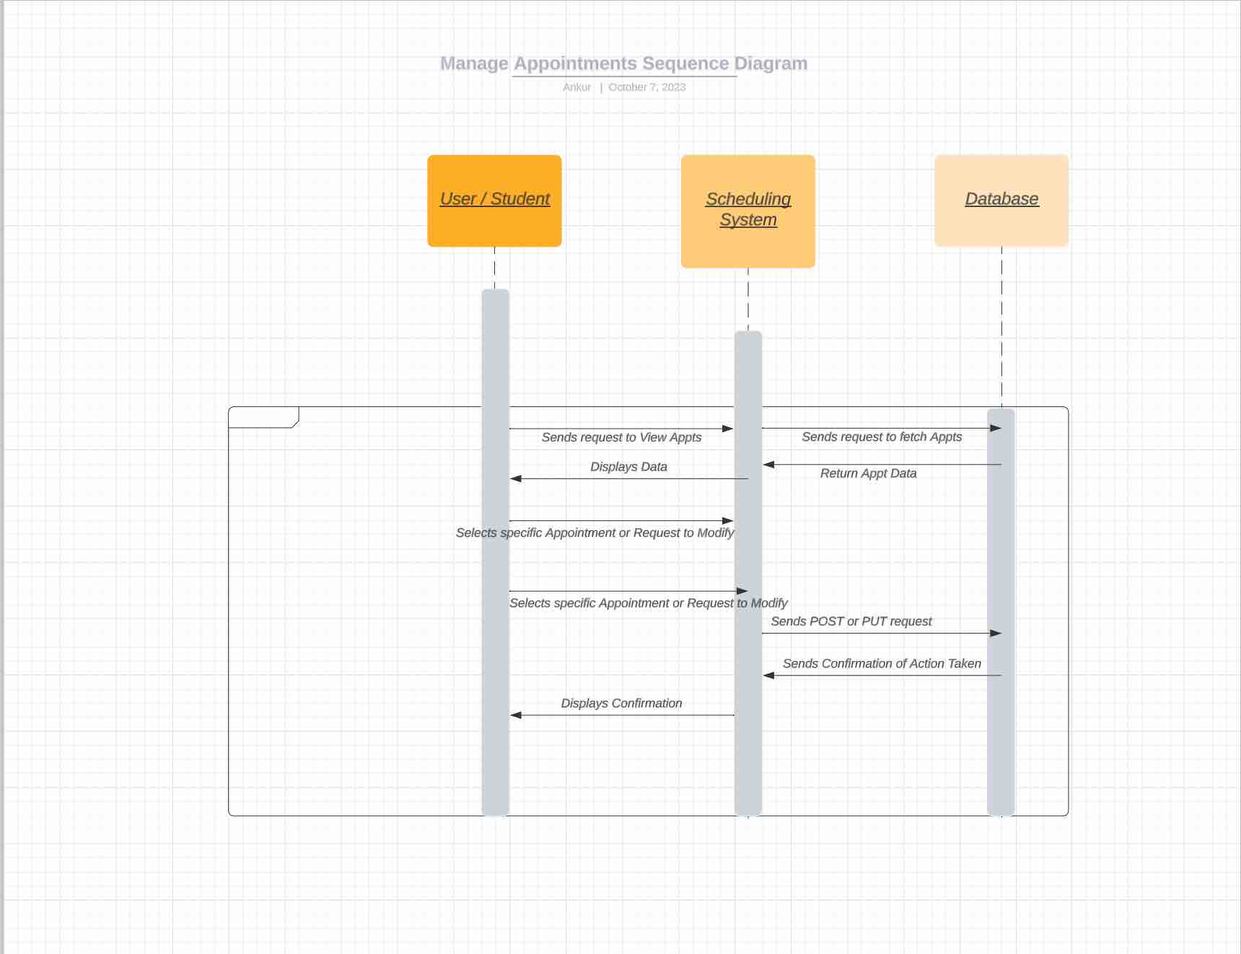

### UML Class Diagram

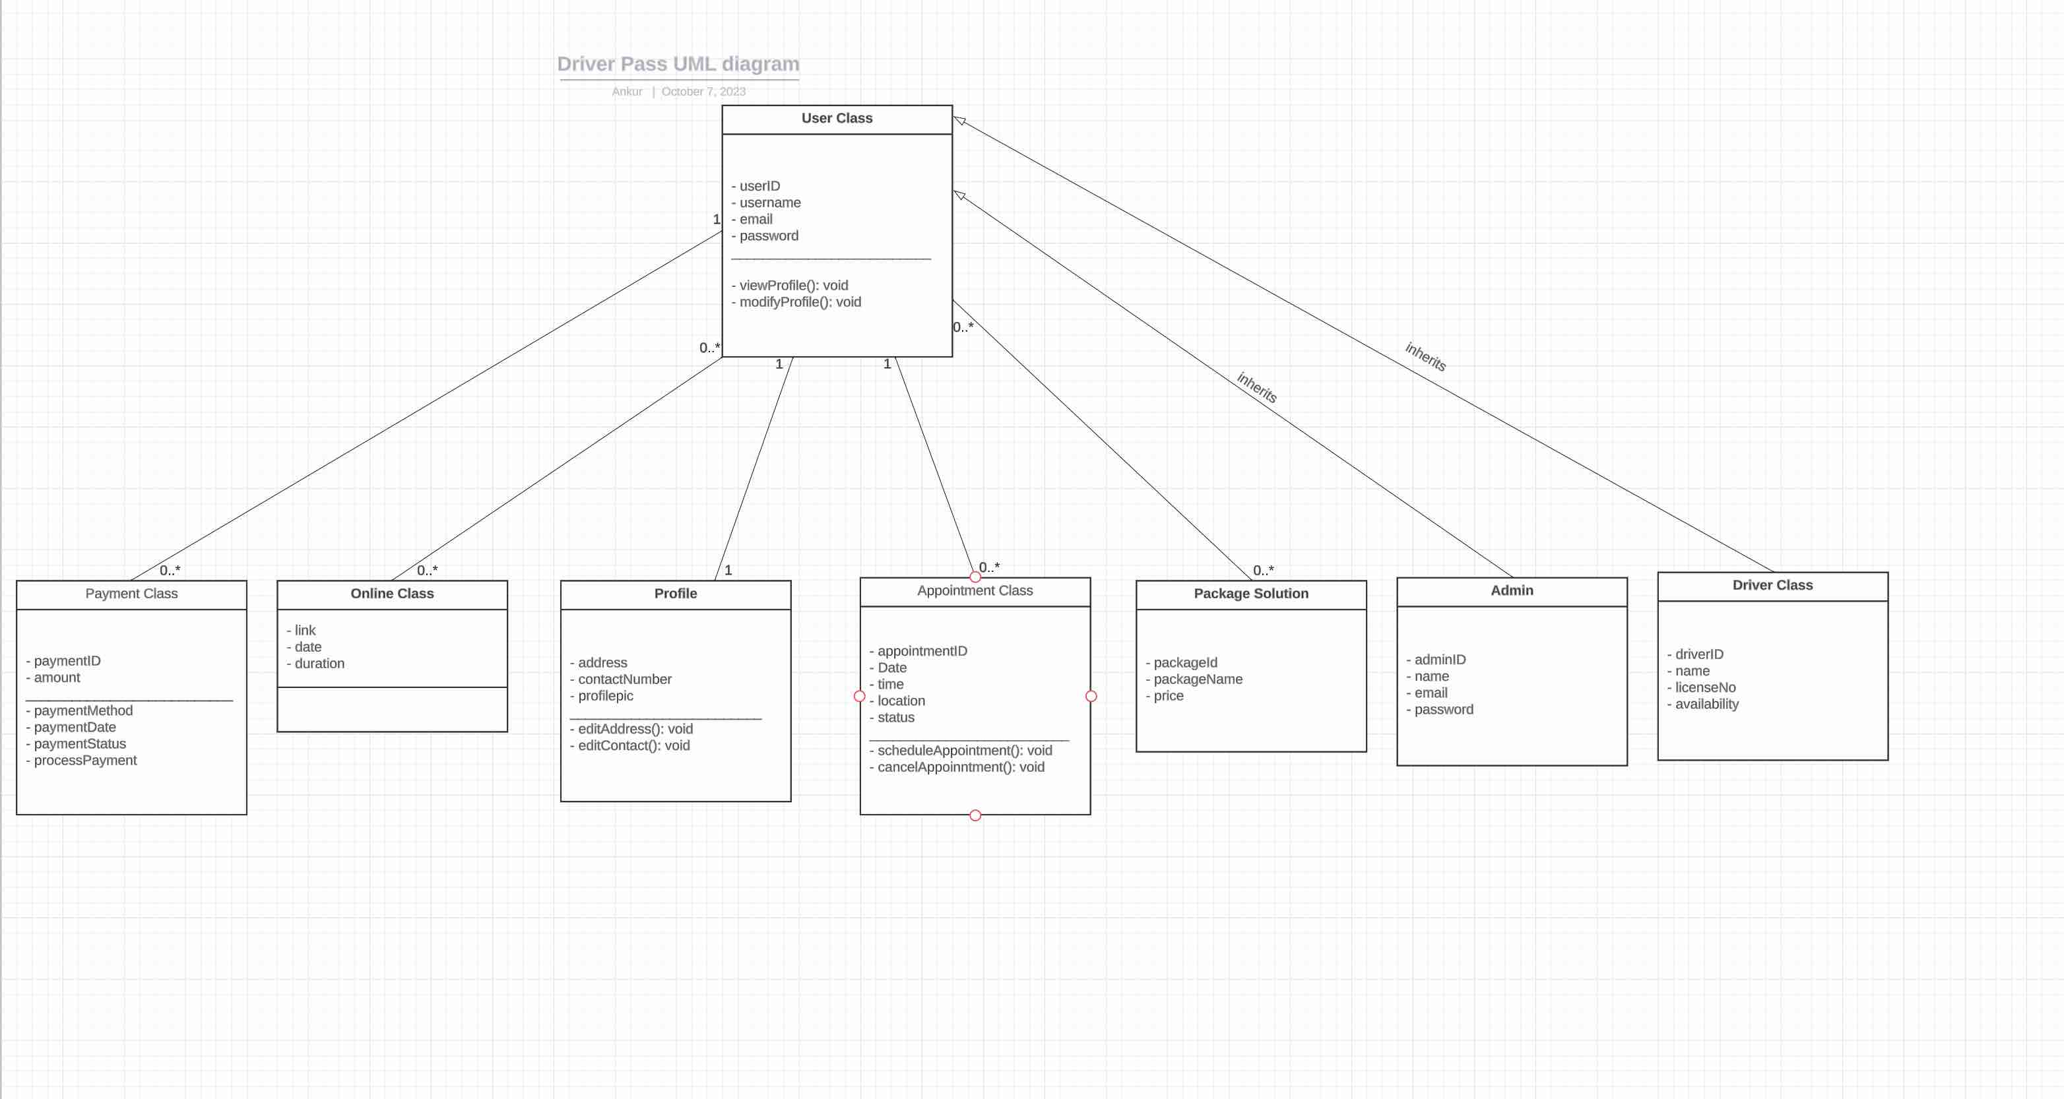

## Technical Requirements

**Technical Requirements of the System:**

Hardware Requirements:

**Server:** This system must include servers and databases. High performance, well

balanced servers with redundancy for backup and failover purposes.

**Client Devices:** Users would need to access the system, thus a need for client devices

such as computers, smartphones or tablets.

**Network Devices:** Routers, Switches and firewalls to ensure secure and smooth

communication between system components.

Sofware Requirements:

**Database Management:** To manage and store appointment data, user profiles and for

every other piece of state, including admin work.

**Backend Framework:** Backend work to manage and create logic around scheduling,

taking tests and even authentication.

**Frontend Tools:** Designing the user Interface that considers performance,

usability and accessibility.

Tools & Infrastructure:

**Cloud Hosting Platform:** Services like AWS, Google Cloud or Azure to host the system.

**Version Control:** Tools like GIT for management.

**CI tools:** Jenkins, Travis CI for automating parts of the software delivery process.

**Security:** To keep the client's data secure, ensuring SSL certificates and encryption are

being used.

**APIs & Integrations:** If the scheduling or payment systems communicate to external

system, they must be integrated securely.

User Accessibility:

**Web browsers:** Ensure compatibility with major browsers like Chrome, Firefox,

Safari and Edge.

**Mobile Support**: Ensure that the application is built mobile first.

**Support Infrastructure:** Ensure that Users and Admin can contact someone for

assistance.

Misc:

**Payment Gateway:** Ensuring that payments infrastructure – processing and depositing-

is secure with a well-known payment gateway.

**Email System:** For notifications and communications, receipts and other contact with

Users, Admins, and drivers.

**Backup and Recovery:** Ensure data safety and availability.